**Exercise: DOM Events**

Problems for exercises and homework for the ["JavaScript Advanced" course @ SoftUni](https://softuni.bg/courses/js-advanced)". Submit your solutions in the SoftUni judge system at <https://judge.softuni.bg/Contests/2763/DOM-Manipulation-and-Events-Exercise>

**Environment Specifics**

Please, be aware that every JS environment may **behave differently** when executing code. Certain things that work in the browser are not supported in **Node.js**, which is the environment used by **Judge**.

The following actions are **NOT** supported:

* **.forEach()** with **NodeList** (returned by **querySelector()** and **querySelectorAll()**)
* **.forEach()** with **HTMLCollection** (returned by **getElementsByClassName()** and **element.children**)
* Using the **spread-operator** (**...**) to convert a **NodeList** into an array
* **append()** in Judge (use only **appendChild()**)
* **prepend()**
* Always turn the collection into an **JS array** (forEach, forOf, et.)

If you want to perform these operations, you may use **Array.from()** to first convert the collection into an array.

## Sections

You will receive an **array** of strings. For each string, create a **div** with a **paragraph** with the **string** in it. Each paragraph is initially **hidden (display:none)**. Add a **click** **event** **listener** to **each div** that **displays** the **hidden** paragraph. Finally, you should **append** all divs to the element with an **id** "**content**".

**Example**

 🡪 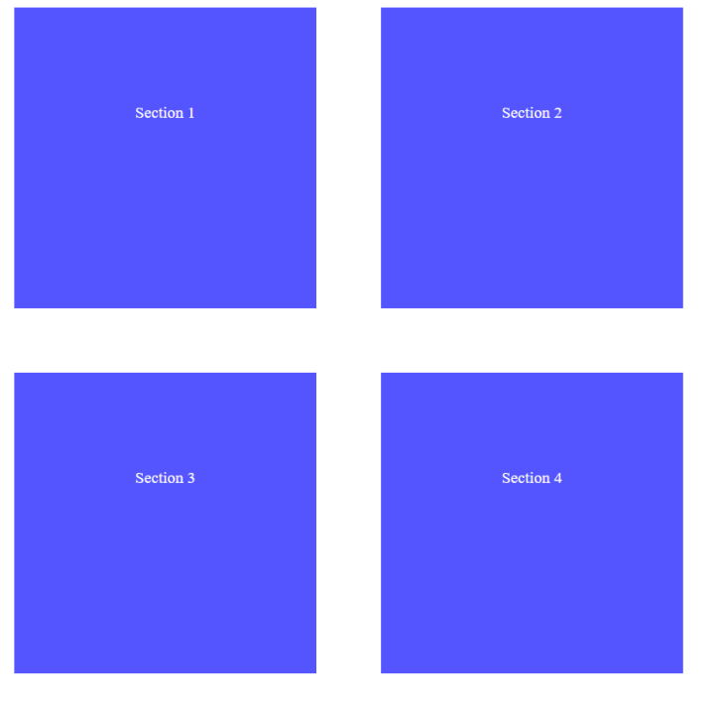

## Time Converter

Create a program that **converts** different time units. Your task is to add a **click** event listener to **all** [**CONVERT**] **buttons**. When a button is **clicked**, read the **corresponding** input field, **convert** the value to the **three other** time units and **display** it in the input fields.

**Example**

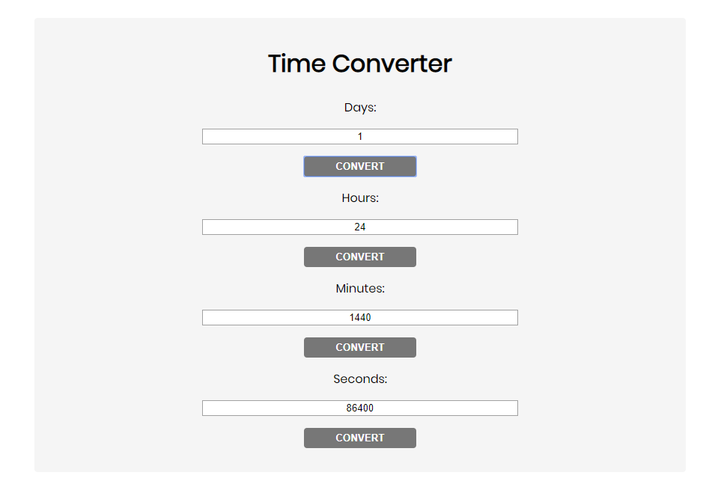

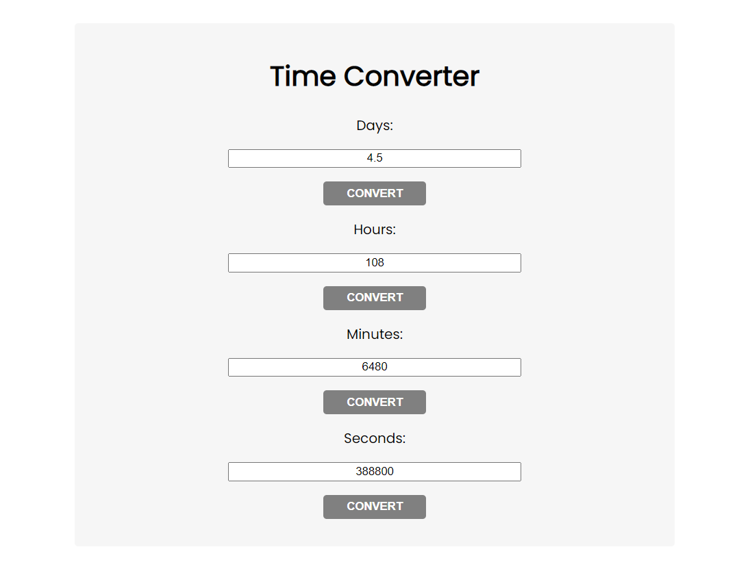

One day is equal to 24 hours/1440 minutes/86400 seconds. Whichever button we **click,** the input fields should **change** depending on the added value on the left. (For example, if we write 48 hours and click convert the days, the field value should change to 2).

## Locked Profile

In this problem, you should **create a JS functonality** which **shows** and **hides** the additional

information about users.

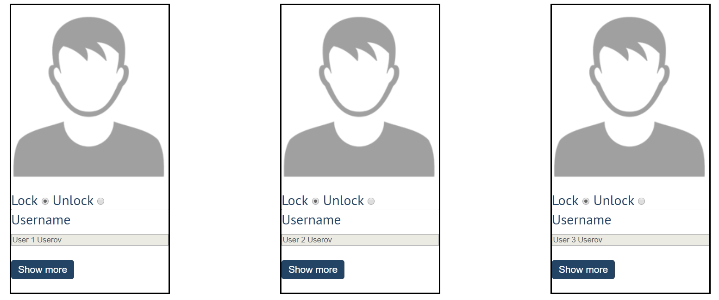

When one of the [**Show more**] **buttons** is clicked, the **hiden information** inside the div should

be shown, only if **the profile is not locked**! If the current profile is **locked,** nothing should

happen.

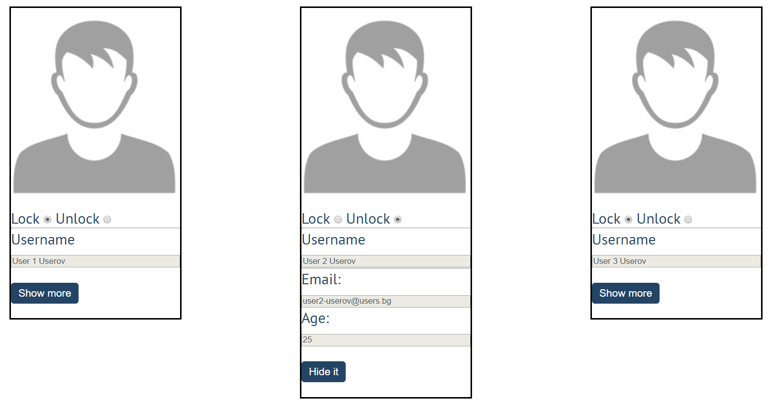

If the **hidden information is displayed** and we **lock** **the profile again**, the [**Hide it**] button

should **not be working**! Otherwise, when the profile is **unlocked** and we click on the **[Hide it]**

button, the new fields must hide again.

## Fill Dropdown

Your task is to take values from **input** fields with **ids "newItemText"** and **"newItemValue"**.Then you should create and append an **<option>** to the **<select>** with **id** **"menu".**

**Example**

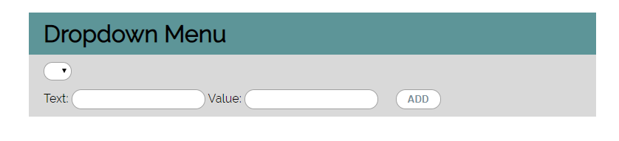

**Hints**

* Your function should take the values of **newItemText** and **newItemValue**. After that you should create a new **option** element and set its **textContent** and its **value** to the newly taken ones.
* Once you have done all of that, you should **append** the newly created **option** as a **child** to the **select** item with id **"menu".**
* Finally, you should **clear** the value of the two **input** fields.

## Encode and Decode Messages

In this problem, you should **create a JS functonality** which **encodes and decodes some**

**messages which travel to the network.**

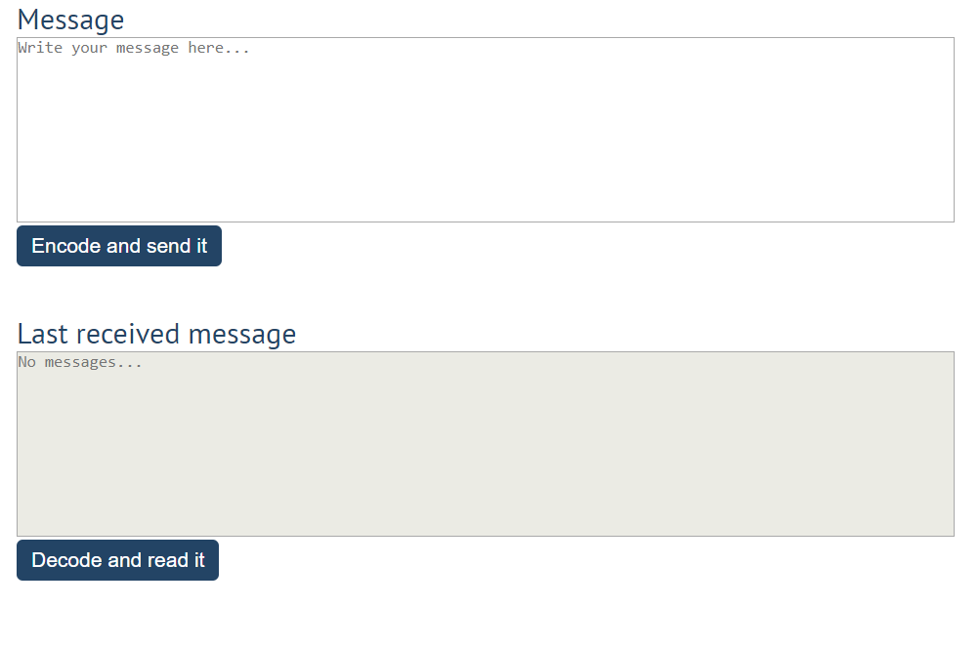

This program should contain **two functionalities**.

The first one is to **encode the given message** and **send it** to the **receiver**.

The second one is to **decode the received message** and **read it (display it)**.

When the [**Encode and send it**] **button** is clicked, you should get the given message from the first textarea. When you get the current message, you should encode it as follows:

* **Change** the **ASCII CODE** on **every single character** in that message when you **add 1** to the current **ASCII NUMBER**, that represent the current character in that message
* **Clear** the **sender** **textarea** and **added** the encoded message to the **receiver textarea**

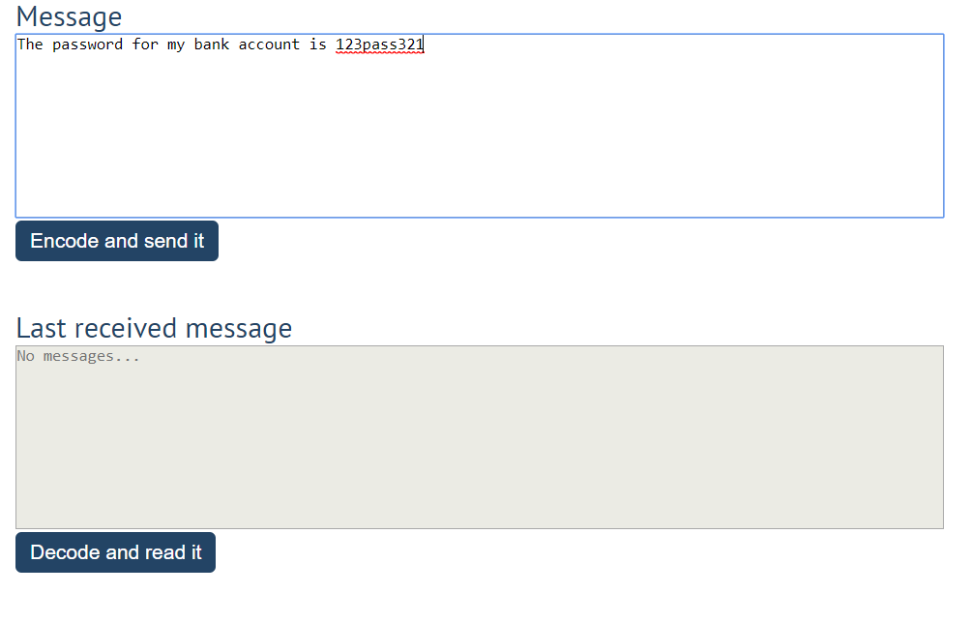

After clicking [**Encode and send it**] **button** the result should be:

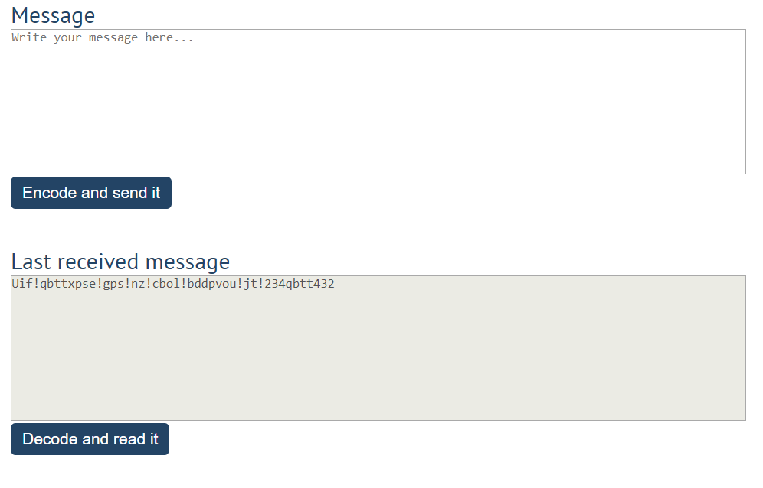

After that, when the [**Decode and read it**] **button** is clicked. You need to get the **encoded message** from **the receiver textarea** and do the **opposite logic** from encoding:

* **Subtract 1** from the current **ASCII NUMBER**, that represents the current character in that message
* Replace the **encoded message** with the already **decoded message** in the receiver textrea, to make it readable

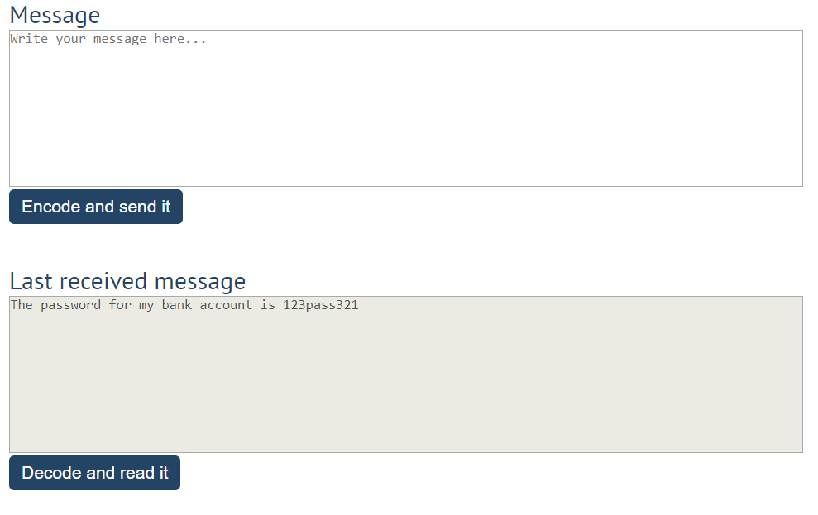

## Furniture

You will be given some furniture as an **array of objects**. Each object will have a name, a price and a decoration factor.

When the **"Generate" button is clicked**, add a **new row to the table** for each piece of furniture with image**,** name**,** price and decoration factor(code example below).

When the **"**Buy**"** button is clicked, get all **checkboxes that are marked** and show in the result textbox the **names** of the piece of furniture that **were checked**, separated by a **comma** and **single** **space** (**", "**) in the following format: **"Bought furniture: {furniture1}, {furniture2}…"**.

On the next line, print the total price in format: **"Total price: {totalPrice}"** (formatted to the second decimal point). Finally, print the average decoration factor in the format: **"Average decoration factor: {decFactor}"**

### Input Example

**[{"name": "Sofa", "img": "https://res.cloudinary.com/maisonsdumonde/image/upload/q_auto,f_auto/w_200/img/grey-3-seater-sofa-bed-200-13-0-175521_9.jpg", "price": 150, "decFactor": 1.2}]**

### Examples

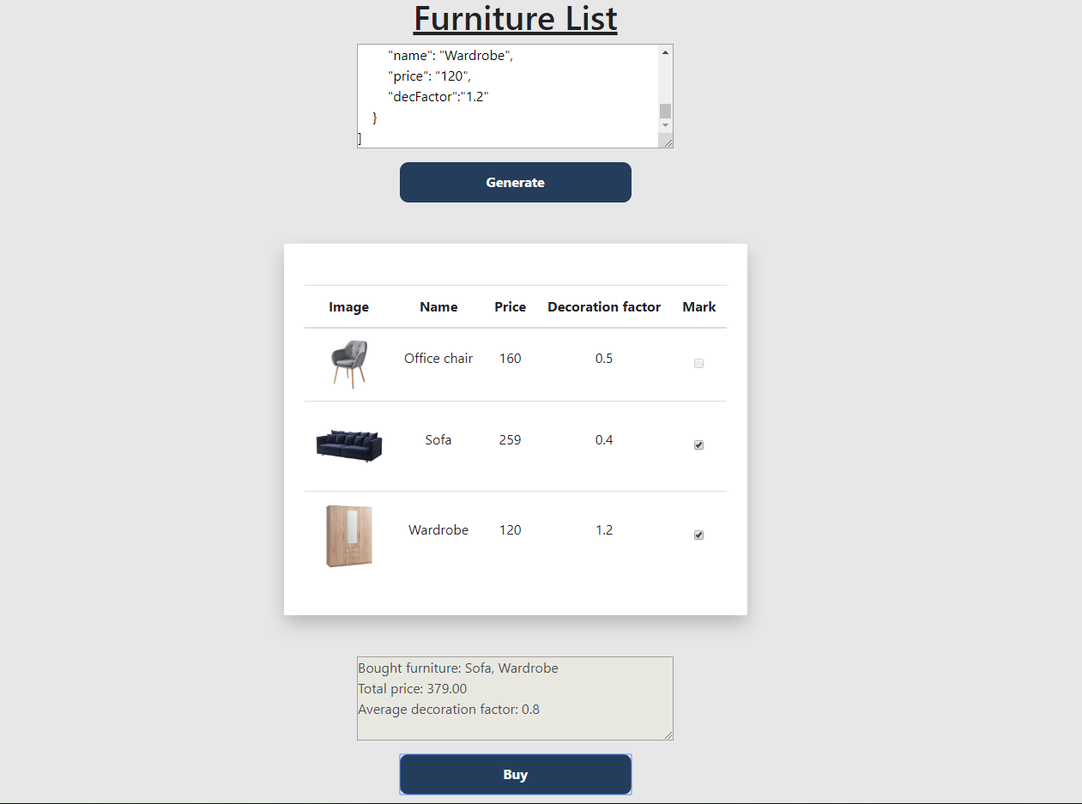

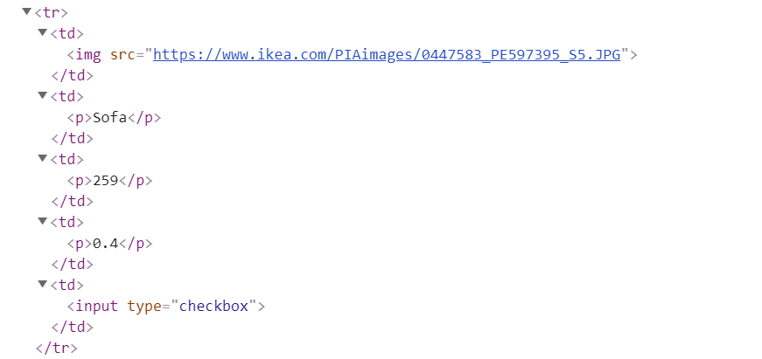

## Distance Converter *

Your task is to convert from **one** distance unit to **another** by adding a **click** event listener to a button. When it is clicked, **read** the value from the input field and **get** the **selected** option from the **input** and **output** units drop downs. Then **calculate** and **display** the converted value in the **disabled** output field.

**Example**

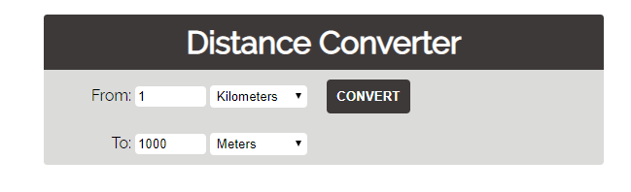

**Hints**

* Multiply the incoming distance by the following conversion rates to convert to meter
* Divide to convert from meters to the required output unit
* To see which option is selected, read the properties of its parent: **value** gives you the value of the selected option (as displayed in the HTML), **selectedIndex** gives you the 0-based index of the selected option. For example, if miles are selected, **inputUnits.value** is "**mi**", **inputUnits.selectedIndex** is **4**. Option text is irrelevant
* Use the following table information to do that:

|  |  |
| --- | --- |
| **1 km** | **1000 m** |
| **1 m** | **1 m** |
| **1 cm** | **0.01 m** |
| **1 mm** | **0.001 m** |
| **1 mi** | **1609.34 m** |
| **1 yrd** | **0.9144 m** |
| **1 ft** | **0.3048 m** |
| **1 in** | **0.0254 m** |

function attachEventsListeners() {

    let inputTextElement = document.getElementById('inputDistance');

    let outTextElement = document.getElementById('outputDistance');

    let convertButton = document.getElementById('convert');

    convertButton.addEventListener('click', convertDistance);

    function convertDistance(e){

        let inputValue = Number(inputTextElement.value);

        let inputUnits = Array.from(document.querySelectorAll('#inputUnits option'));

        console.log(inputUnits);

    }

}

## Sudomu *

Write a function that implements **SUDOMU** (**Sudoku inside the DOM**).

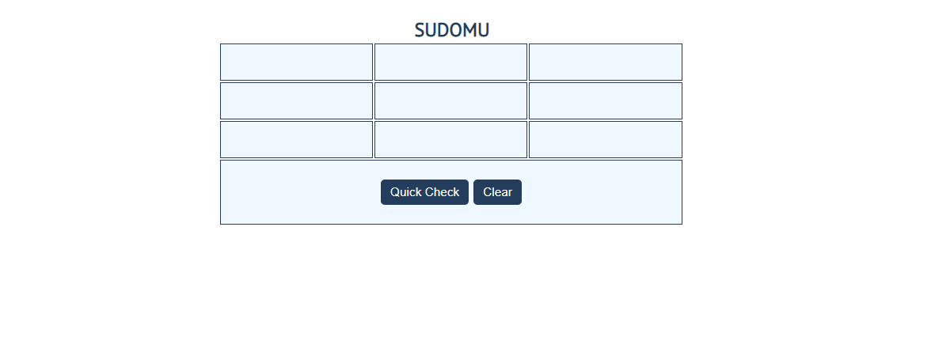

The rules are simple and they are **the same** as the **typical sudoku game** (for more information,

click [here](https://sudoku.com/how-to-play/sudoku-rules-for-complete%20beginners/))

If the table is filled with the **right numbers**, and the "Quick Check" button is **clicked**, the

expected result should be:

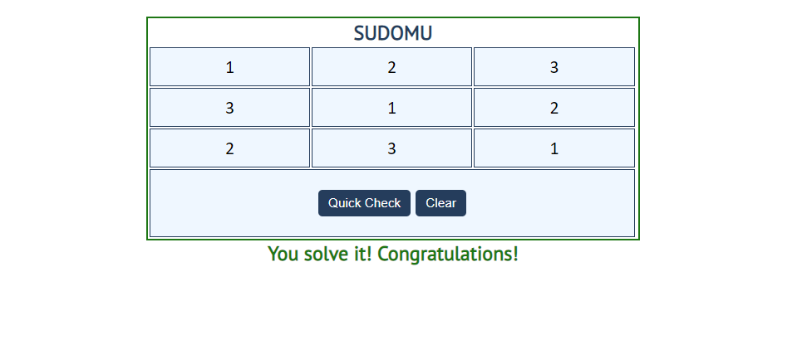

The table borer should be changed to: "2px solid green**".** The text content of the paragraph

inside the div with an **id** "check" must be "You solve it! Congratulations!"

The text color of that paragraph must be **green.**

Otherwise, when the filled table **does not solve** **the sudomu,** the result should be:

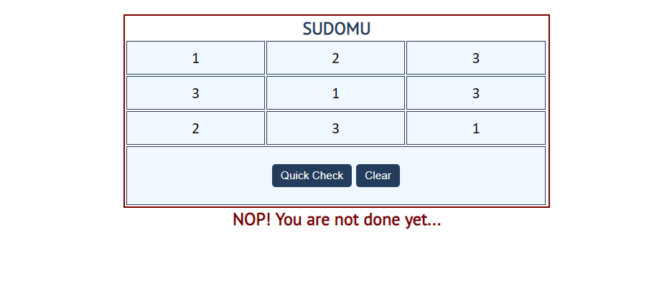

The table border should be changed to: "2px solid red".

The text content of the paragraphinside the div with an **id** "check" must be:

"NOP! You are not done yet..."

The text color of thatparagraph must be **red!**

The"Clear"button **clears the whole** **SUDOMU (removes all numbers)** and the **paragraph**

**which contains the messages. It also removes the table border.**



## JavaScript Quizz *

Write a function that has the functionality of a quiz.

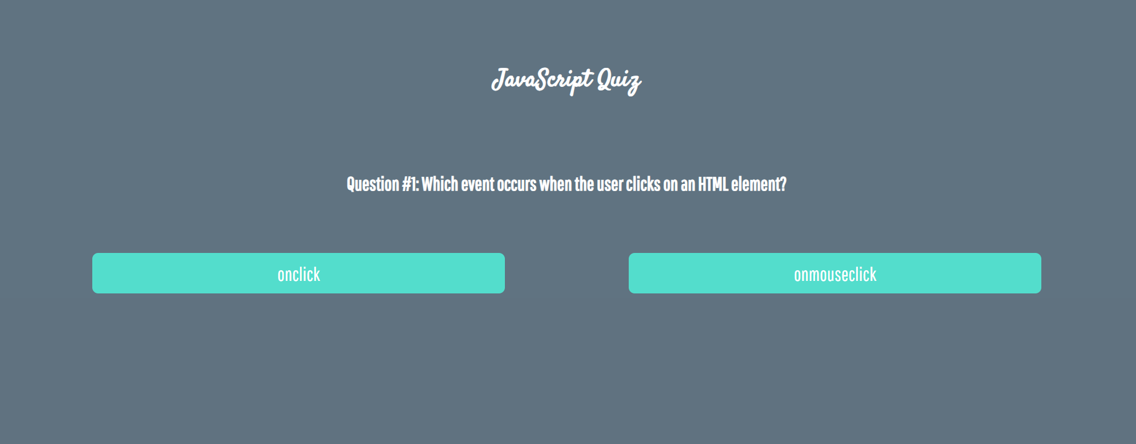

There are three **sections** that contain **one question** **and 2 possible answers.**

**The right answer is only one!**

When one of the **list elements is clicked,** the next section **must appear (if any…)**.

After all three questions have been answered, the results ul must **appear,** (Use **'none'** and **'block**' to hide and show the question sections), and the results must be added in the h1.

If all questions are answered correctly, you should prin the following message:   
"You are recognized as top JavaScript fan!"

Otherwise, just print "You have {rightAnswers} right answers".

The right answers are (onclick**,** JSON.stringify() **and** A programming API for HTML and XML documents).



